**QMST 5332 Paper Review**

**Optimizing Fire Station Locations for the Istanbul Metropolitan Municipality**

Submitted By:

Josh Hershman, Ruchi Dilip Kukde, Neeraj Kumar Reddy Panta, and Shefalika Upadhay

**Introduction**

In 2008, the Istanbul Metropolitan Municipality (IMM) decided to review their fire stations for compatibility with their initiative *Istanbul, My Project.* The municipality, with over 13 million people and centuries of historic and cultural significance, sent out an open invitation to its universities to collaborate on projects that would uplift and improve the city for every citizen. Emel Aktas, Özay Özaydın, Burçin Bozkaya, Füsun Ülengin, and Sule Önse, the authors of this paper, responded to the call and submitted proposed solutions to aid the city in assuaging their fire station problem (Aktas et al., 2013). Indeed, the IMM serves 790 mutually exclusive districts within Istanbul and aims to respond to each and every fire call within 5 minutes. The aforementioned historical nature of the city makes response time doubly important; losing any building to a preventable fire would be a tragedy.

To begin, the 5 researchers utilized a literature review to discuss the background for their two proposed solution models: a set-covering cost-minimization problem and a maximal coverage maximization problem. They found previous papers from other researchers that dealt with very similar coverage problems; indeed, being able to maximize emergency response coverage while simultaneously minimizing response time has been of high interest to many around the world. Both models employ binary decision variables to model the problem. After deciding on the proper models by analyzing previous literature, historical data on the 60 current fire stations located in the IMM was employed in conjunction with the use of a GIS tool in order to both visualize the city and understand travel times and limitations as things currently stood within the city. From there, a 790 x 790 proximity matrix was devised to show coverage based on 5-minute proximity to a fire station. The result of this matrix was then used as the core of the two integer programming models. As if two different models were not exhaustive enough, the researchers also defined 10 specific scenarios which primarily focused on coverage and budget requirements. These scenarios were key to generating a solution that compared with what the Istanbul Metropolitan Municipality had envisioned at the onset of their issuing the challenge. Ultimately, the results of their study were presented and the council opted to employ a scenario that had budgetary constraints. While 100% coverage, achieved in the models that were aimed at maximizing coverage, would be ideal in a perfect world, the council was ultimately bound by budget constraints that made this infeasible. Despite the inability to provide perfect coverage to all of Istanbul, the researchers were incredibly effective at creating a proposed solution that worked within the constraints provided to them by the municipality. Indeed, the original coverage within the city hovered just under 60%. After creating and solving a mathematical model, the researchers were able to increase this number by about 25%, improving coverage for the city into the 80s. An added benefit of adding new stations appeared; many areas were now covered by two fire stations, with selection locations even being triply covered. This aids in reducing the strain on key stations in particularly busy districts, allowing others to pick up the slack in the areas overlapping between the two. Indeed, opening the first ten new stations increases coverage by about a third (7.2%) of the overall increase within the model. The average increase in coverage per new station is roughly .4%, meaning that each additional opening has a tangible effect on the safety of the city. As a whole, the researchers’ solution to the problem presented to them was a masterclass in mathematical optimization.

**Analysis**

In the article, the solution methodology is explained in detail using two subsections: data acquisition and scenario analysis. In this report, we review these approaches as follows.

1. **Data Acquisition**

In the paper, the authors have considered fire stations in four size categories: A, B, C, and D, and further focus on the fire incident data for 1994–2006 from IMM from each sub-district, and use ArcGIS, a GIS set-covering and maximal-covering model which enables users to store, retrieve, manipulate, analyze, or spatial data sets. Its central element is the use of a location-referencing system to enable users to analyze the data about a specific location relative to the display, edit, and analyze spatial data by linking digital map layers to spatially enabled databases. The layers of the GIS map relative to the fire station location problem include data sets, such as roads, and fire station locations.

The authors use ArcGIS on a digital data set of Istanbul by considering the types of roads and travel speeds to calculate travel times between sub-districts roads which can be categorized as highways, major streets, and average speeds of firefighting vehicles. Local streets are reported to have the lowest average speed because they have the narrowest lanes, the highest congestion level, and the slowest traffic flow because of constant interruptions by these attributes for each road segment. In the article, the authors represent each subdistrict as a single point for distance calculations; to do this, they take the polygonal footprint of each building in the subdistrict, convert each footprint to a single point at the polygon’s center of gravity and merge points by considering average. After determining all such candidate locations, they create a proximity matrix in which each row and column represents an origin and destination subdistrict, respectively. It is reachable from a subdistrict with a fire station within five minutes. Then, they use the ArcGIS network analyst extension to calculate this matrix, which indicates the sub-districts that are within five minutes of travel time of each other, using the actual street network. special areas (e.g., airports) in the matrix because of their reverse direction (e.g., because of road networks).

1. **Scenario Analysis**

There are two models used to analyze the problem: set-covering and maximal covering models. Appendix A shows the various scenarios employed in the article as solution approaches and their corresponding descriptions. The authors employ Scenario 1 as the baseline. In Scenarios 2-5, the authors have considered the cost of opening fire stations and aim to minimize the cost of coverage. On the other hand, scenarios 6 - 9 in the table incorporate weights of covering sets of sub-districts and the goal is to seek maximum coverage. The number of fire incidents is especially important in these scenarios since the objective function is to maximize coverage related to service requests. In the article, the authors use the solutions of the even-numbered scenarios ( see appendix A) in the odd-numbered scenarios. A logistic function is used for forecasting the number of fire incidents. A sensitivity analysis is conducted for a range of budget limitations and for comparison of the results to the existing budget.

1. **Mathematical Model**

Based on the characteristics of the problem described, there are two models used in this study. They are: the set covering model and the maximal covering model. These are integer programming models solved using mathematical programming and optimization software. In the article, the main objective is to minimize the number of new fire stations to serve all sub-districts within at most five minutes.

* **Set covering model**

In order to solve the problem, the authors developed a set covering model by gathering the input data, defining the decision variables, and defining the objective and objective function and constraints. In this article, the authors have used compact form notation of mathematical models. The input data is acquired using ArcGIS as described in the solution methodology. For the set covering problem, the decision variables are defined as binary decision variables where 1 corresponds to if the fire station is opened in subdistrict j and 0 otherwise. They are defined as: $x_{jk}$ where $j ϵ \{1,2,...,790\},$ the set of candidate fire station locations (sub-districts) and $k ϵ \{A< B, C, D\}$, the set of candidate fire station types. The objective is to minimize the cost of opening fire stations. The mathematical model and the terminologies are given below.

|  |  |
| --- | --- |

In this developed model (Aktas et al., 2013), equation (A1) is the objective function that minimizes the cost of opening fire stations. Equation (A2) ensures that the right type of station is opened to respond to service requests from each subdistrict. Equation (A3) ensures that only one type of fire station is opened in a subdistrict. Equation (A4) represents the binary decision variable of locating a fire station in a subdistrict.

* **Maximal covering model**

The next approach for solving the model involved a maximal covering model with additional budget constraints. The objective of the model is to cover the maximum possible number of locations given budget constraints. In this model (Aktas et al., 2013), equation (B1) is the objective function that maximizes the coverage of service requests in each sub-district. Equation (B2) ensures that the right type of station is opened to respond to service requests from each subdistrict. Equation (B3) ensures that the number of fire stations opened is within the set limit. Equation (B4) ensures that only one type of fire station is opened in a subdistrict. Equation (B5) represents the binary decision variable of opening fire stations. Equation (B6) represents the binary decision variable of covering the service requests in subdistricts.

|  |  |
| --- | --- |

1. **Results**

The largest model has 3,208 binary variables and 6,416 constraints and requires 0.781 seconds to solve using a personal computer with an Intel Core™ 2.20 GHz processor and 2 GB RAM. Table 1 shows the results for each scenario generated by the CPLEX 11.0 solver.

Table 1: Results of analysis for each scenario (Aktas et al., 2013)

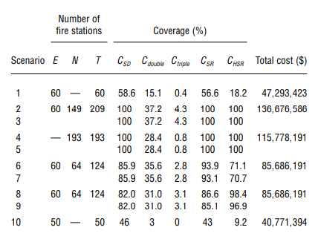

For each scenario, three aspects of coverage were evaluated. The first is the percentage of sub-districts covered (CSD). Regarding this aspect, the percentage of sub-districts covered twice (Cdouble) and (Ctriple) three times is used to determine the percentage of sub-districts within a five-minute travel time of at least two and three fire stations, respectively. The second aspect is the percentage of service requests (i.e., the percentage of fire incidents) (CSR) in the sub-districts covered (CSR). The third aspect is like the second; however, the authors change the weight of the sub-districts in the objective function according to the distribution of heritage service requests (CHSR). For all three aspects of coverage, it is assumed that a subdistrict (or all fire incidents in that subdistrict) is covered if the subdistrict's center of gravity is reachable from a fire station within 5 minutes. Generally, either the entire area or the main inhabited area in that area meets these criteria. The costs of opening the required new stations in US dollars using the exchange rate as of March 3, 2009, conversion where 1 USD = 107257 TRY is calculated. Appendix A shows the detailed coverage calculations. Scenario 1 in Table 2 shows that at the time the project was started, the coverage of service requests in Istanbul was 56.6 percent; for heritage service requests, it was 18.2 percent. Scenario 2 requires a total of 209 stations to reach 100 percent coverage, with 149 new stations opening at a cost of $136,676,586. This number of stations is approximately 8.3% more than the optimum scenario in Scenario 4. (i.e., 193 stations for 100 percent coverage). Following the historical fire incident data, Scenario 4, the model proposes opening type D fire stations since types (A, B, C) are typically underutilized and type D is sufficient to respond to most fire events.

Additionally, sub-districts in Scenario 2 (37.2 percent), Scenario 4 (28.4 percent), Scenario 6 (35.6 percent) and Scenario 8 (31.0 percent) are double covered (Cdouble); however, no model includes this multi-coverage feature. The difference between Scenario 2 and 4 is as follows: Scenario 4 minimizes the number of fire stations in the city without considering the existing fire stations; As a result, station locations will be more randomly distributed on the city map. Additionally, 59.6% of these dual-covered sub-districts are of historical importance (i.e., have a higher-than-average number of heritage objects). Such sub-districts have at least two fire stations within a five-minute drive. This finding greatly eliminates the need to locate additional fire stations and the additional costs associated with achieving multiple coverages. If we analyze the results of the forecast scenarios (Scenarios 3, 5, 7, and 9) in Table 2, we find that those scenarios involving future fire service requests with their counterpart's proposed fire service locations (Scenarios 2, 4, 6, and 8) about the same level as their counterparts; this indicates the robustness of the solutions created in scenarios 2, 4, 6, and 8.

During the study in 2009, 58.6 percent of Istanbul (463 of 760 subdistricts) was covered by 60 fire stations. Many populated sub-districts were not served within five minutes, and this was the result of the city expansion or due to a change in road network structure. Based on historical fire data, fire stations in scenario 1 could only respond to 56.6 percent of service requests in under 5 minutes. In scenario 4, 30 fire station locations overlap with existing ones in scenario 1, and 119 in scenario 2. The overlap between these existing fire stations (Scenario 1) and fire stations built from scratch (Scenario 4) is favorable and building new ones is not financially possible. Scenarios 2-5 have no budget limitation, and these offer 100 percent coverage, but other than providing benchmark results, these solutions are not implementable because IMM operates under a fixed budget for this type of infrastructure investment. Scenarios 6-9 have budget restrictions of $38,392,768 for additional stations. This amount is sufficient to build 64 type D fire stations. The result provided the authors with a proposed coverage of 85.9 percent of sub-districts and 93.9 percent of the service requests under this budget constraint (Scenario 6) by fire stations. In scenario 7, (CSR) has decreased by 0.85 percent, and (CHSR) decreased by 0.56 percent. Scenario 8 considers the heritage service requests and produces a solution that covers 82.0 percent of all sub-districts and 86.6 percent of all service requests with an additional 64 fire stations. Although coverage of service requests decreases by 7.3 percent, these scenarios achieve an additional 27.3 percent coverage of the city’s historical assets.

A sensitivity analysis for Scenarios 6 and 8 shows that 38 additional fire stations (162 including the existing 60 and suggested 64) are needed before a significant impact on all coverage types is apparent. Figure 1 shows an increase in all three coverage measures as the number of fire stations increases. An additional fire station will improve coverage by less than 1 percent beyond 38 fire stations. Another sensitivity analysis described in Figure 2 shows a dramatic increase in heritage service request coverage when 35 new fire stations were added, whereas the service requests and subdistrict coverage remained the same. Both sensitivity analysis figures depict different results. Figures 1 and 2 indicate that cost-versus-service level (i.e., coverage percentage) trade-off because opening a new fire station is linear relative to the number of new stations; in addition to the cost of land, the station size and equipment size are fixed since we are working with IMM. These results provide a relation between cost and service levels.

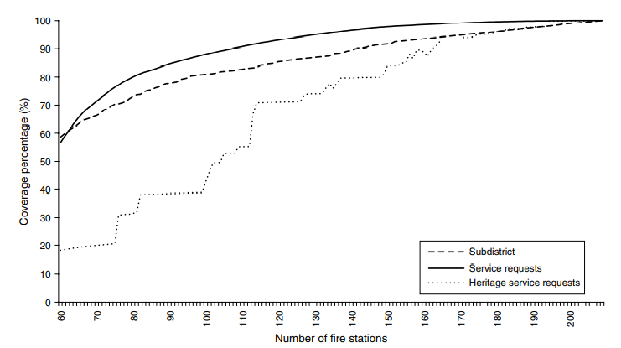

Figure 1: Changes in coverage of subdistricts, service requests, and heritage service requests with the addition of new stations in Scenario 6 (Aktas et al., 2013)

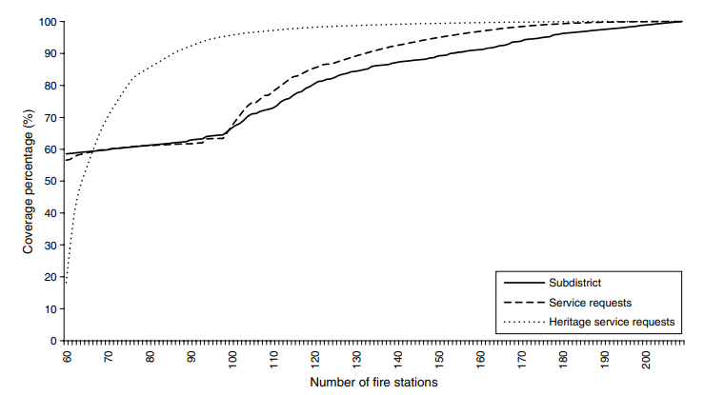

Figure 2: Changes in coverage of subdistricts, service requests, and heritage service requests with the addition of new stations in Scenario 8 (Aktas et al., 2013)

**Conclusion**

At the outset of this project, five professors employed at various universities sought to assist the Istanbul Metropolitan Municipality with their goal in improving fire station coverage for the city. As a location that is of significant cultural and religious significance, not even mentioning being home to a population of eight figures, being able to ensure fast response times across the entire metropolitan area is key to preserving the pieces of history that make Istanbul what it is: a world city. On top of these factors, the number of sub-districts within the municipality itself lends itself to needing an optimized and efficient solution to coordinating fire response amongst first responders. With exceptional backgrounds in engineering, business, and management, the professors set out to find a method that would best equip Istanbul to meet their crucial logistics problem. Sensing that fire station location could easily translate to a mathematical programming model, the researchers began their project with a literature review of past, similar projects. They were easily able to find a wealth of previous papers that detailed other like-minded researchers employing various mathematical programming methods in order to resolve emergency services optimization. Upon concluding their background research and examining the plethora of model choices, the team ultimately decided to employ two different frameworks to meet their needs: set-covering and maximal-covering. While the former model had a goal of ensuring response time was at most five minutes, the latter was designed to incorporate the municipality’s budget restrictions. Utilizing binary decision variables as locations of fire stations and a GIS to generate input data, the researchers successfully built their two models. To be fully exhaustive and assist the city as much as possible in their decision making, these models were further broken down into various scenarios that considered the optimization problem from varied and unique angles. While ten scenarios were ultimately generated, they were largely broken into cost and weighted categories, with the weighting being assigned to various districts within the city. Within models paying no attention to cost, the team’s models were able to generate 100% coverage, with some districts even being covered by one or two additional stations. On the more practical side, employing budgetary constraints, the model’s various scenarios increased coverage by about 25% to the mid-80s. Each additional fire station within the city would increase coverage by about .4%, showing that each new location has a tangible and meaningful impact on safety within the city. The Istanbul Metropolitan Municipality eventually met with the researchers and approved the final results of their mathematical programming models, opting to utilize a scenario that contained budget constraints. As a whole, the group of five professors proved to be exceedingly effective in assisting the city with its fire coverage problem.

**References**

Aktas, E., Ozaydin, O., Bozkaya, B., Ulengin, F., & Onsel, S. (2013). Optimizing Fire Station Locations for Istanbul Metropolitan Municipality. *Interfaces*, *43*, 1-16. 10.1287/inte.1120.0671.

**Appendix A**

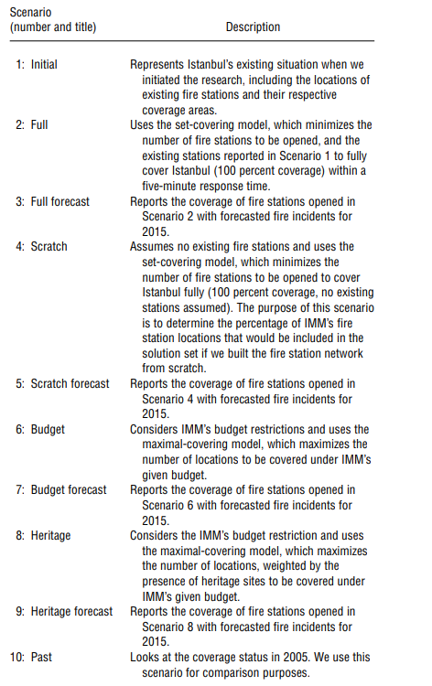

**Appendix B**

